**Associate Data Analyst in SQL DataCamp**

**Course 8: Exploratory Data Analyst in SQL**

**What’s in a Database?**

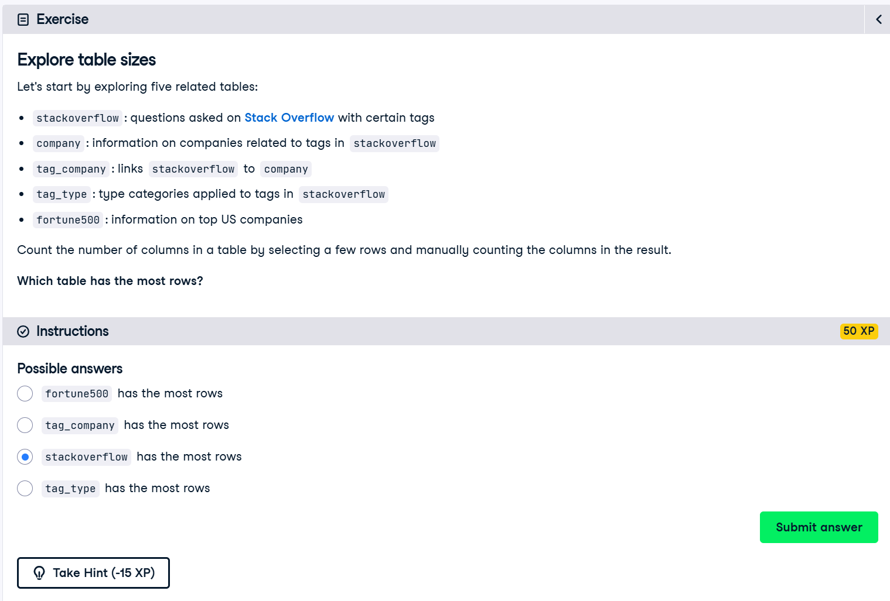

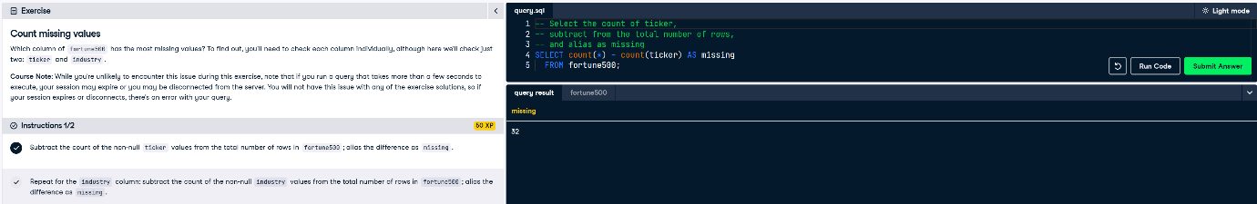

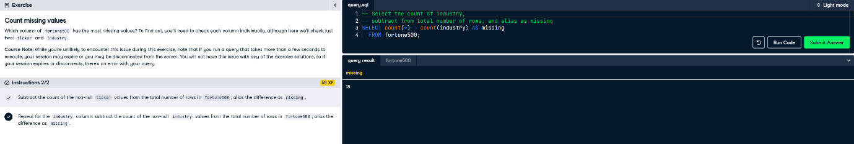

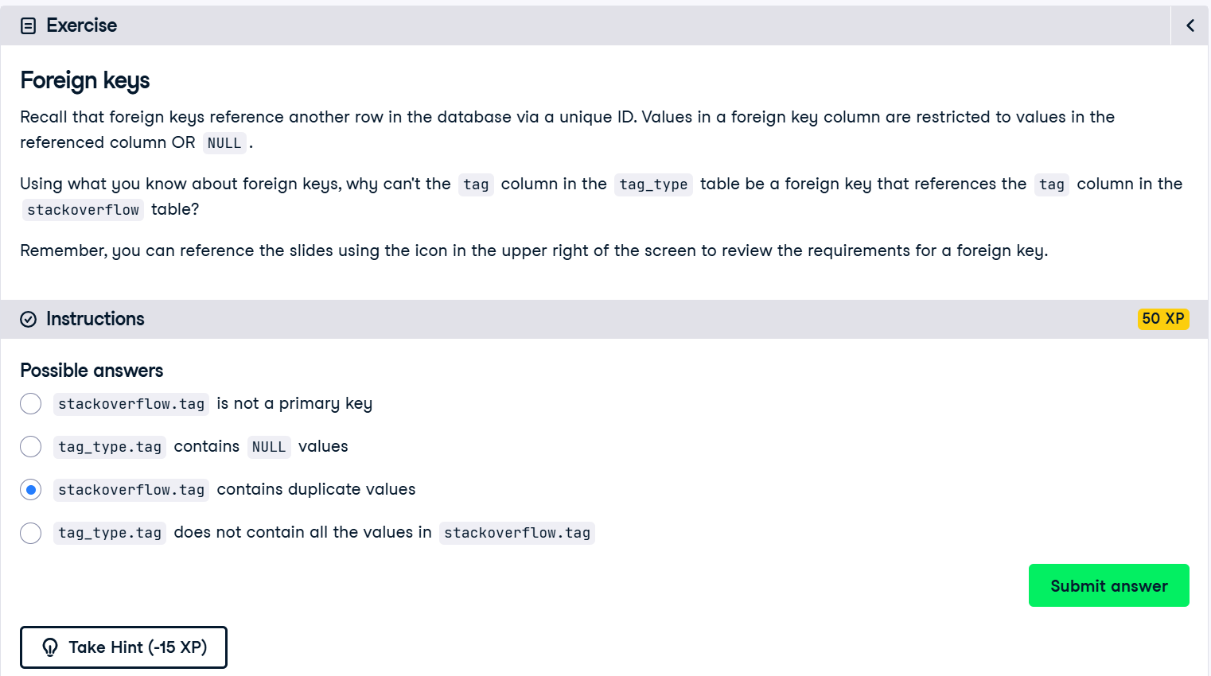

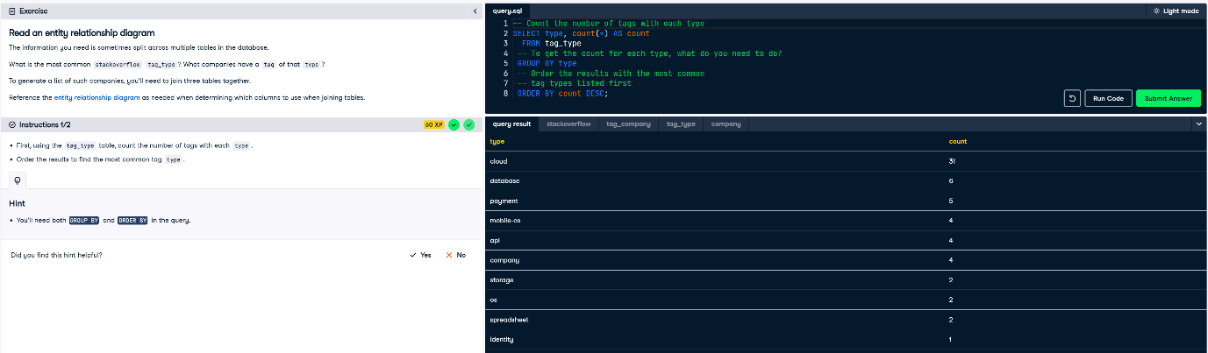

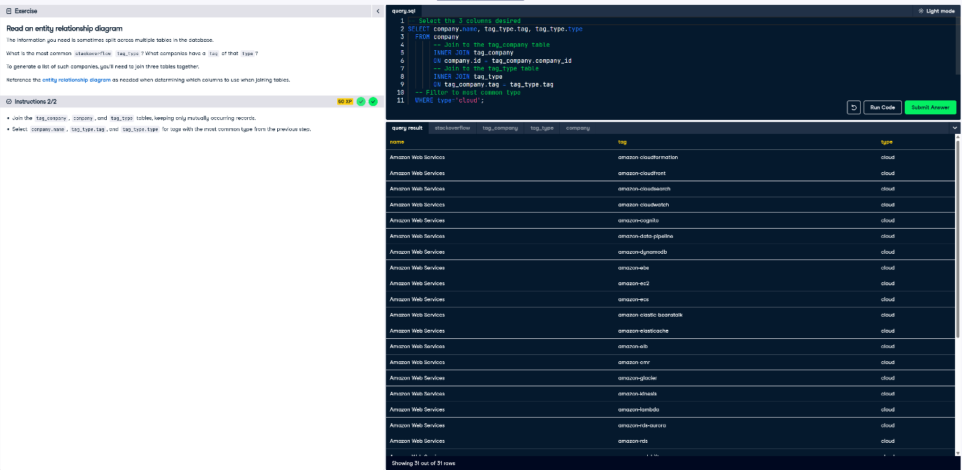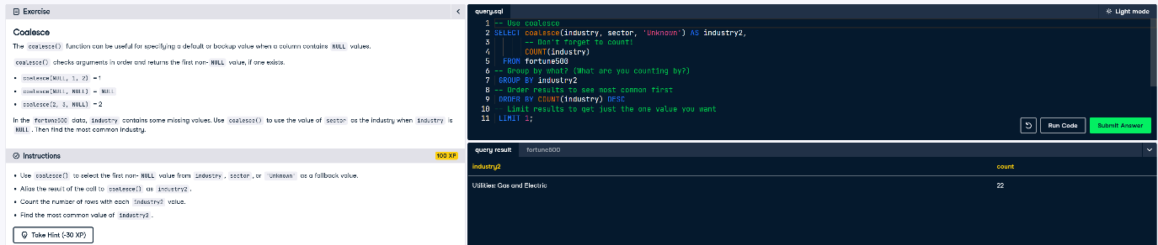

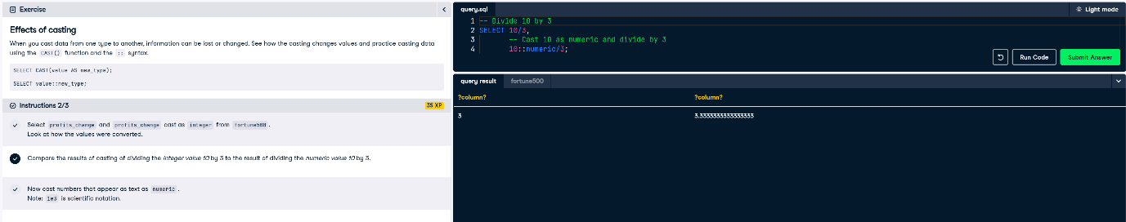

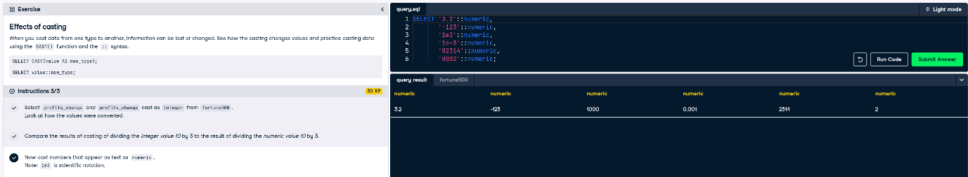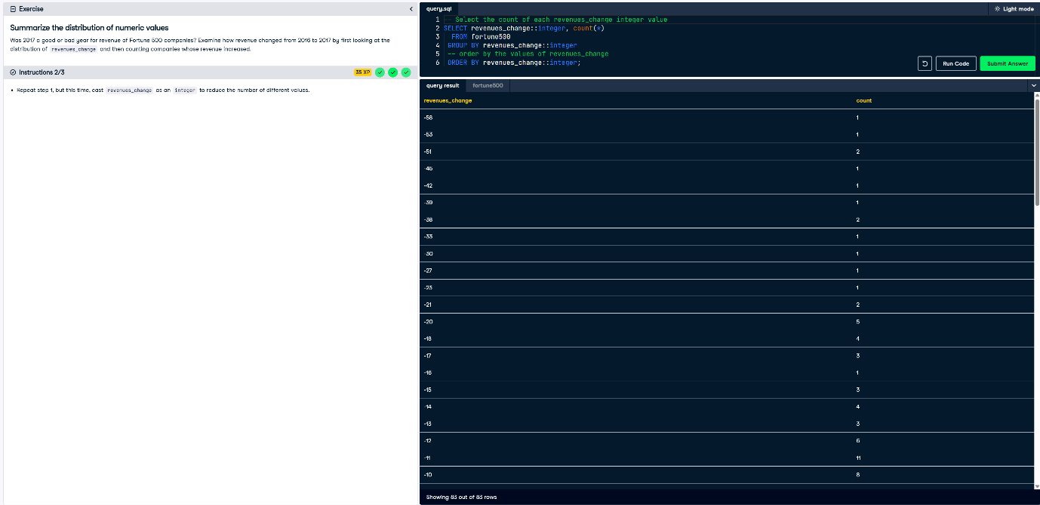

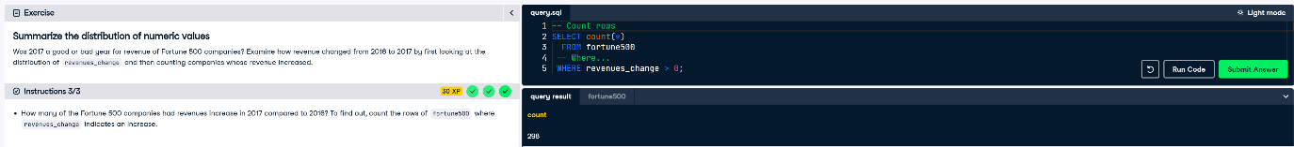

**Summarizing and Aggregating Numeric Data**

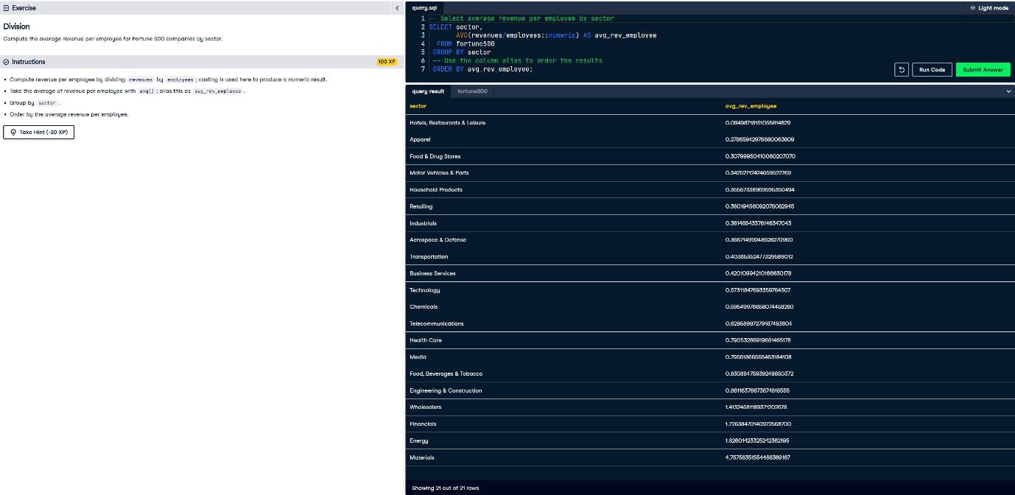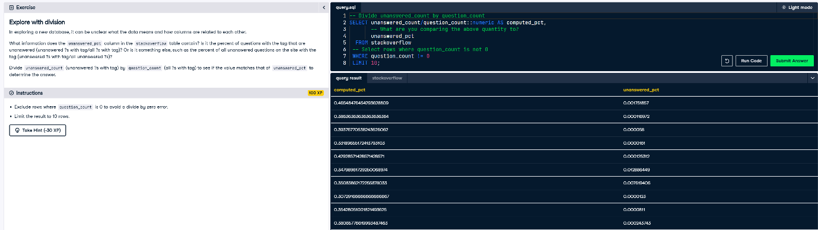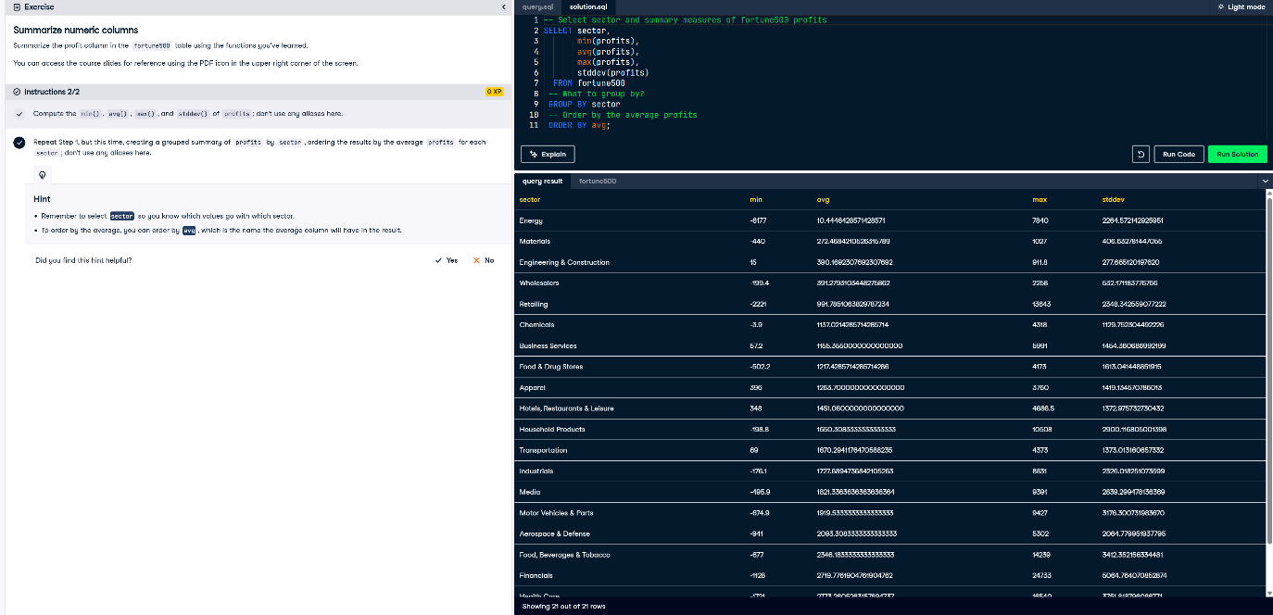

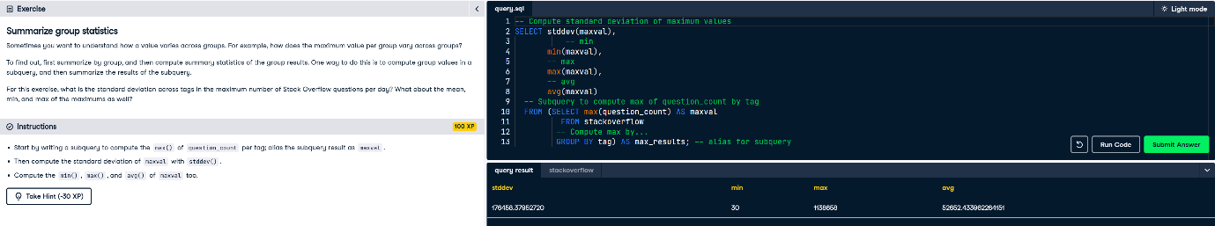

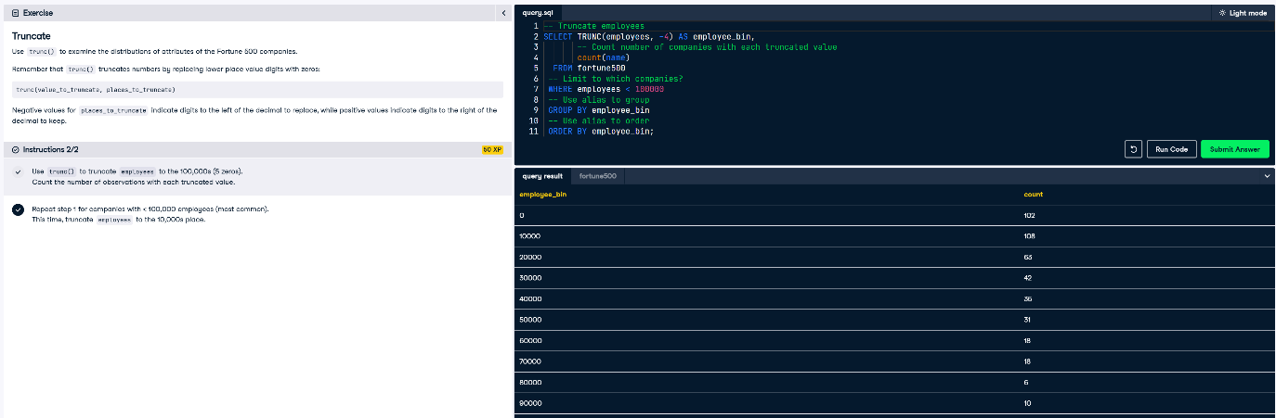

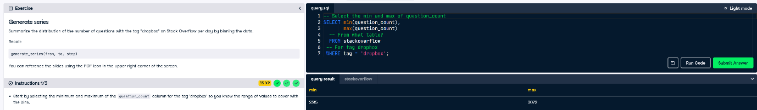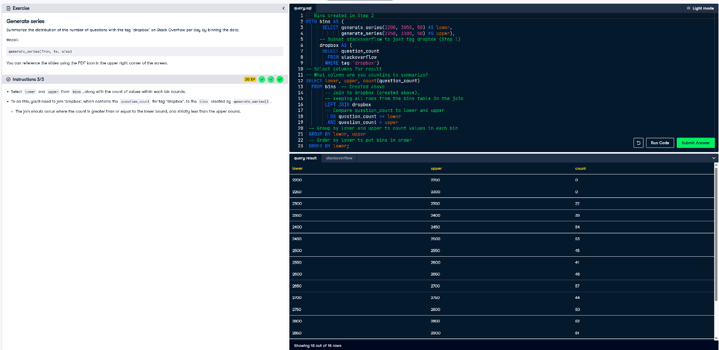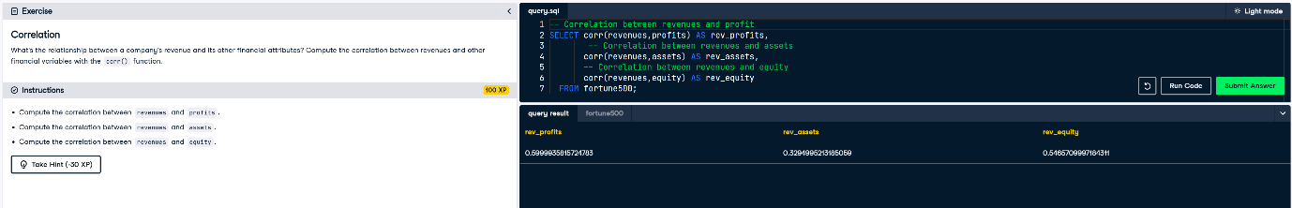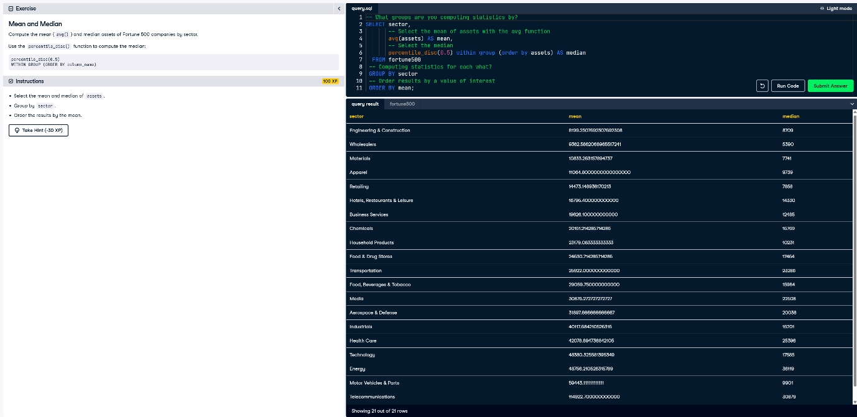

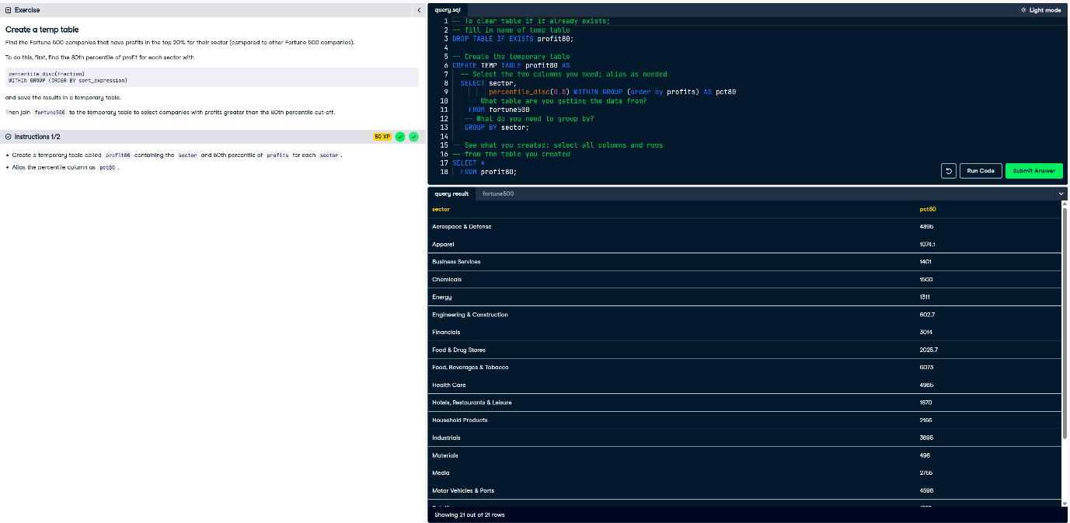

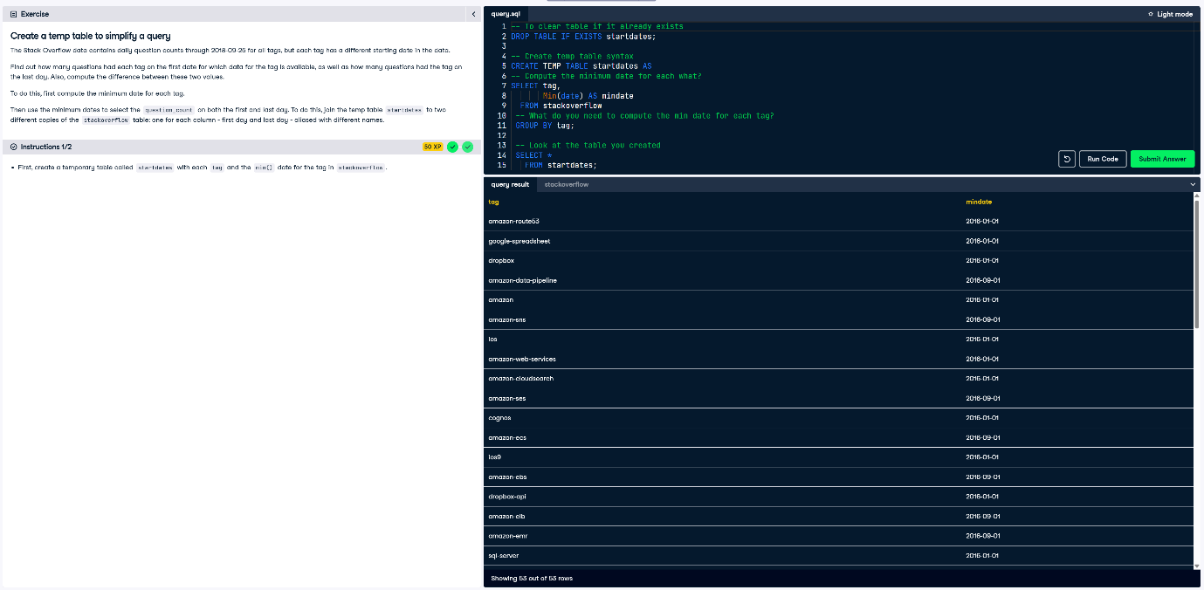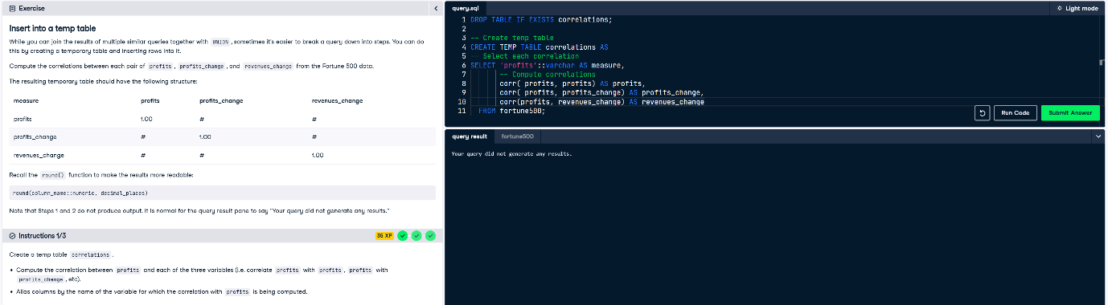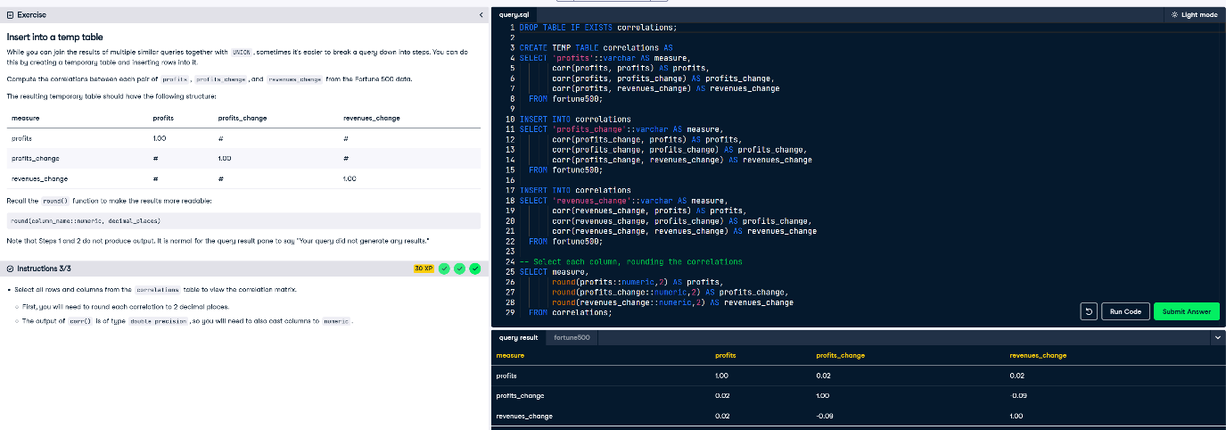

**Exploring Categorical Data and Unstructured Text**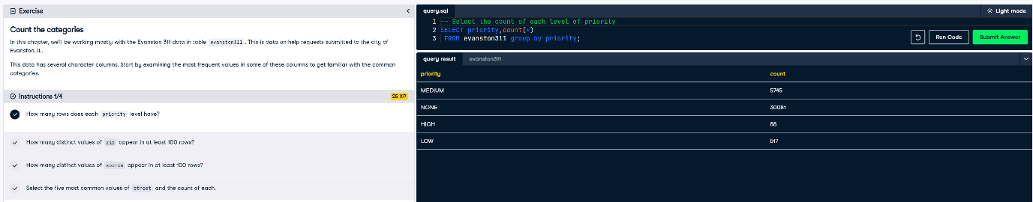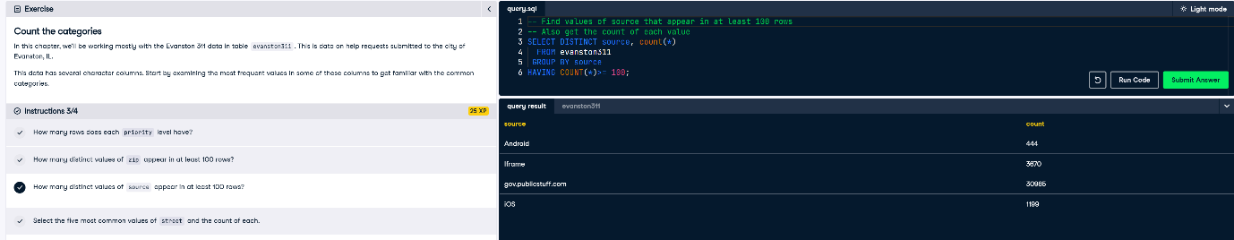

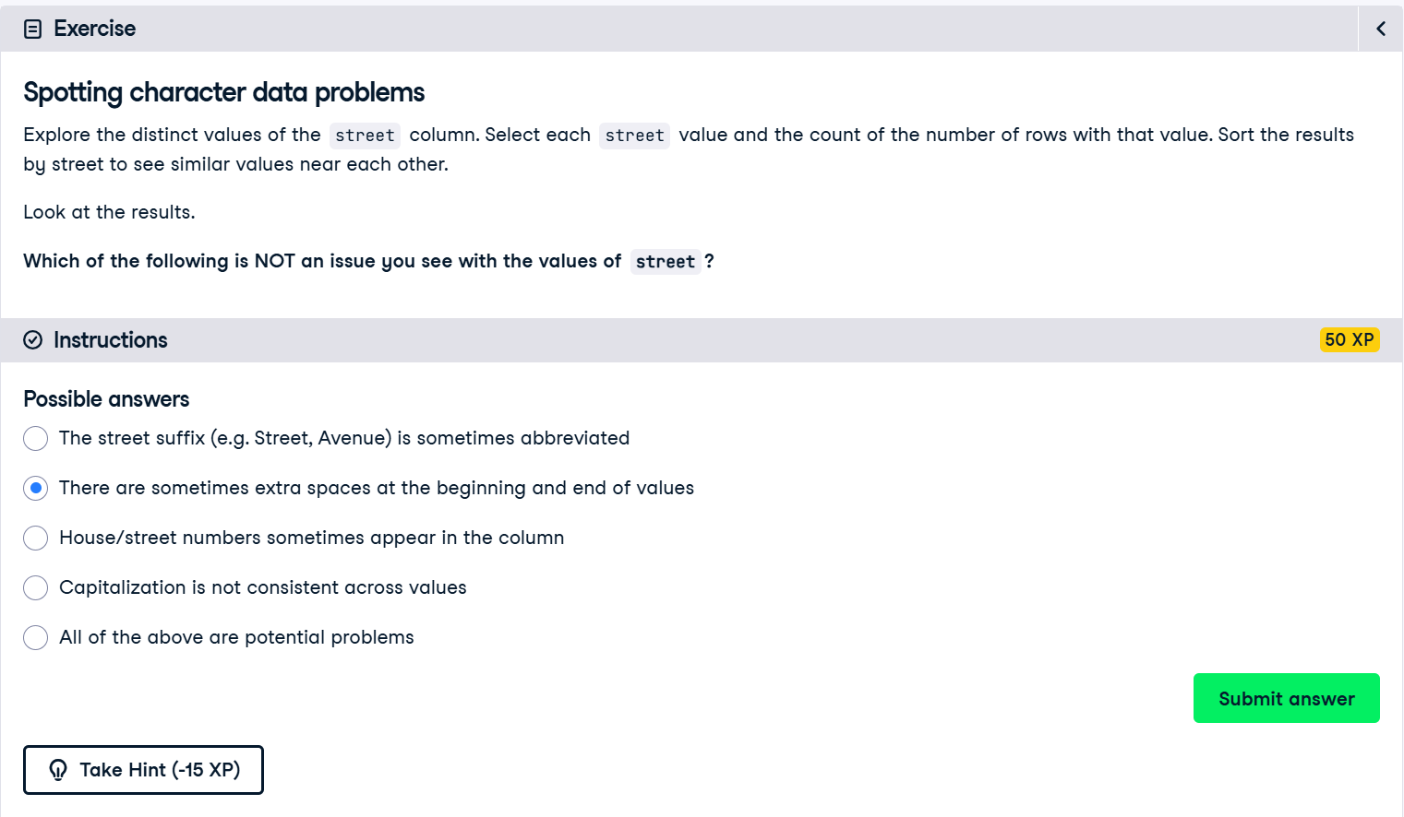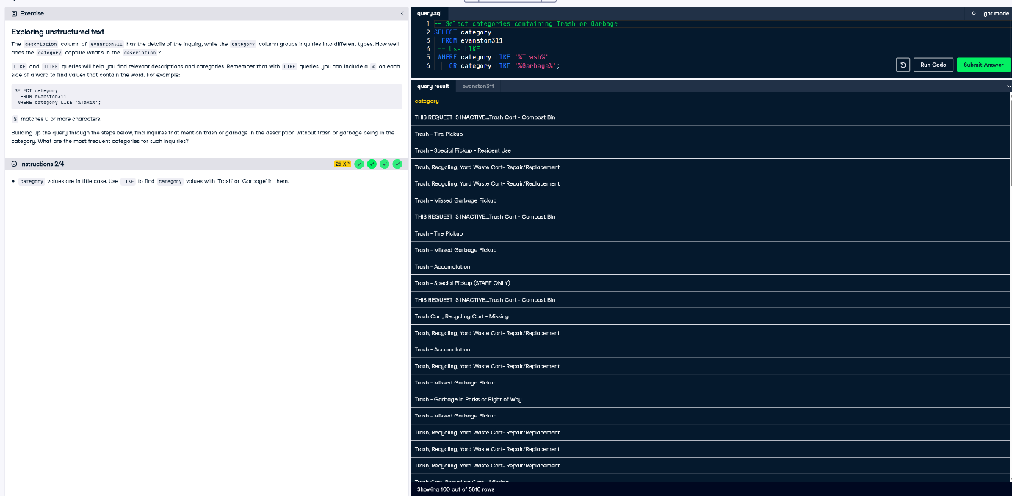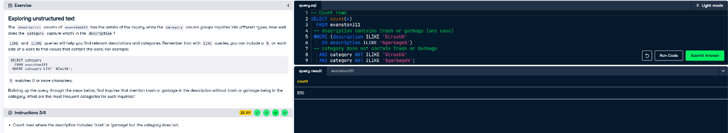

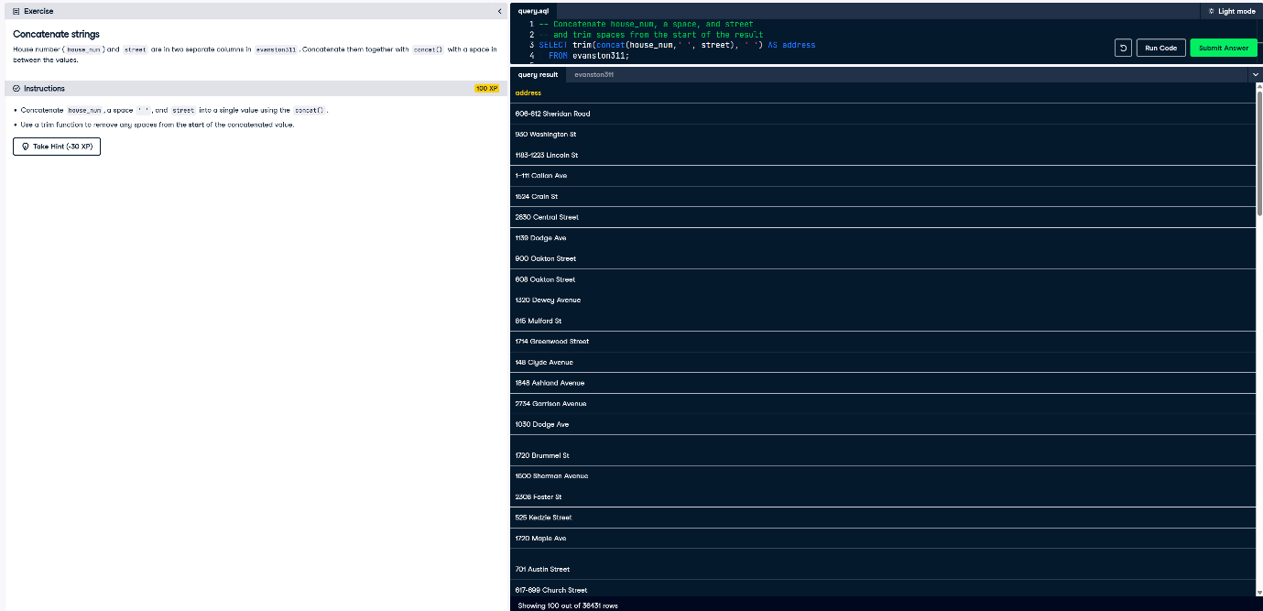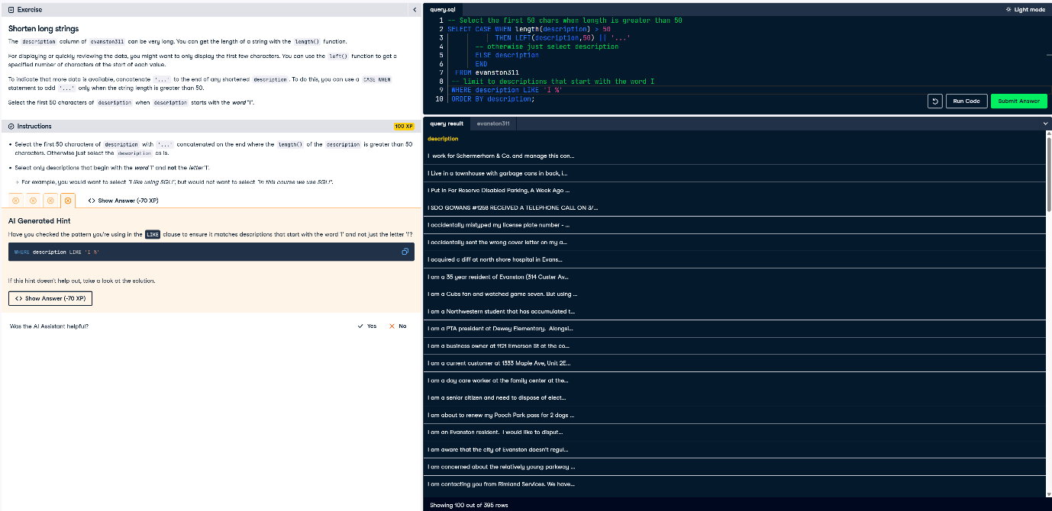

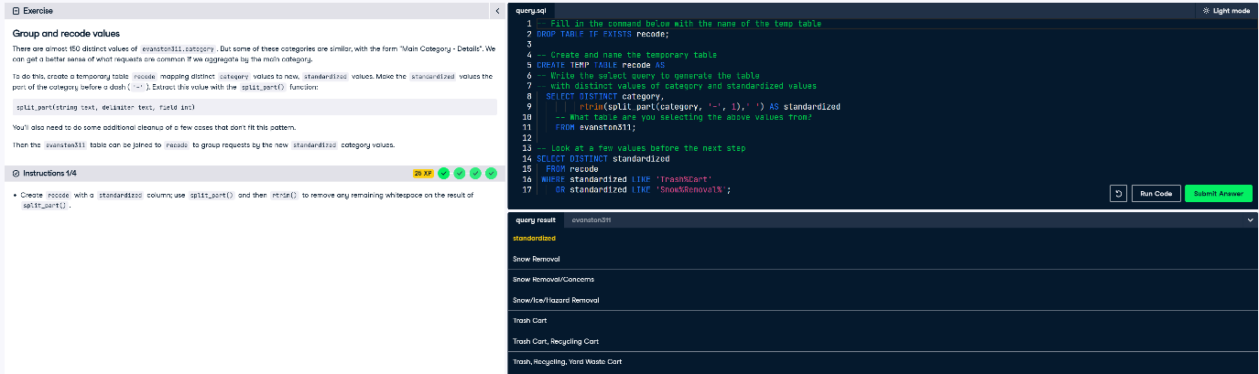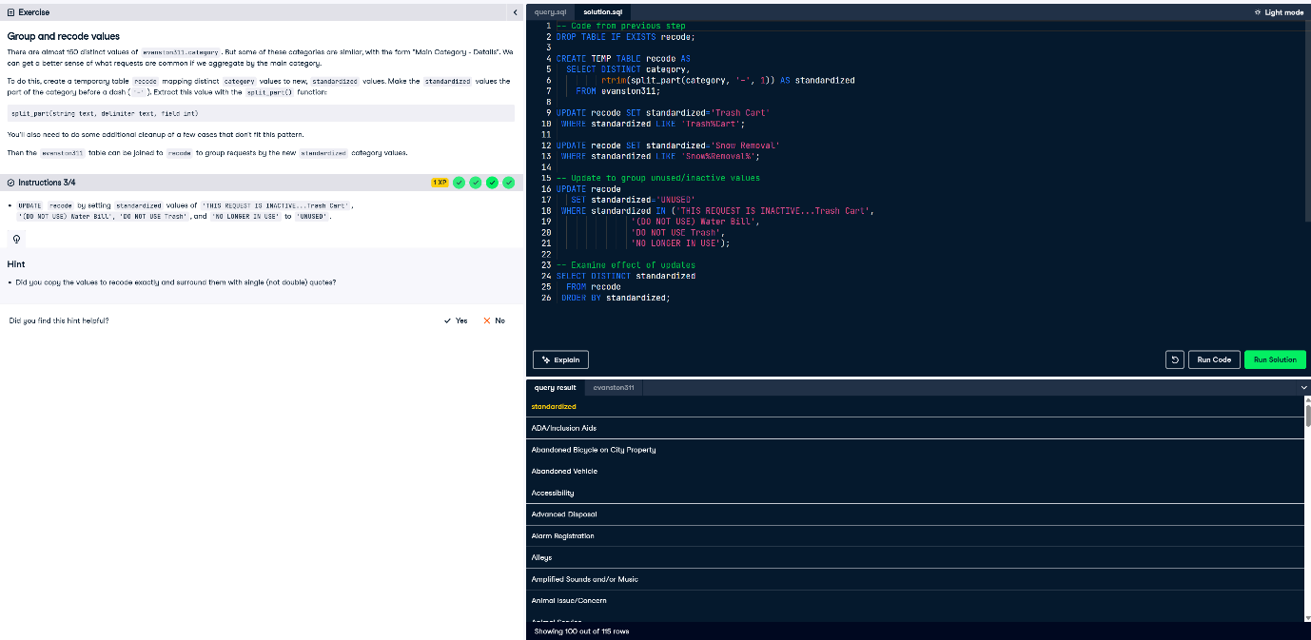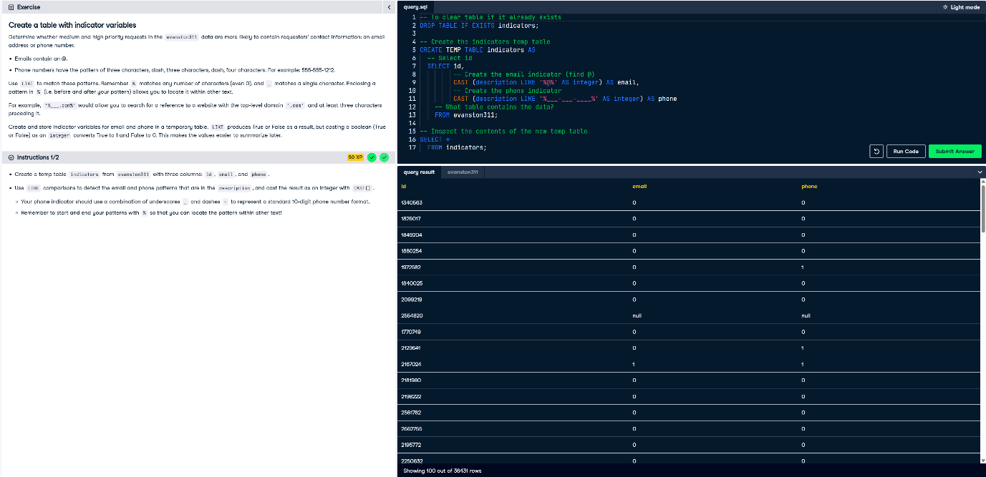

**Working with Dates and Timestamps**

